Vocabulary

|  |  |
| --- | --- |
| Self join | Joins a table to itself |
| Hierarchical queries | Retrieves data based on a natural hierarchical relationship between rows in a table |
| Level | Determines the number of steps down from the beginning row that should be returned by a hierarchical query |
| Start with | Identifies the beginning row for a hierarchical query |
| Tree structure | Specifies the relationship between parent rows and child rows of a hierarchical query |

Try It / Solve It

1. Display the employee’s last name and employee number along with the manager’s last name and manager number. Label the columns: Employee, Emp#, Manager, and Mgr#, respectively.

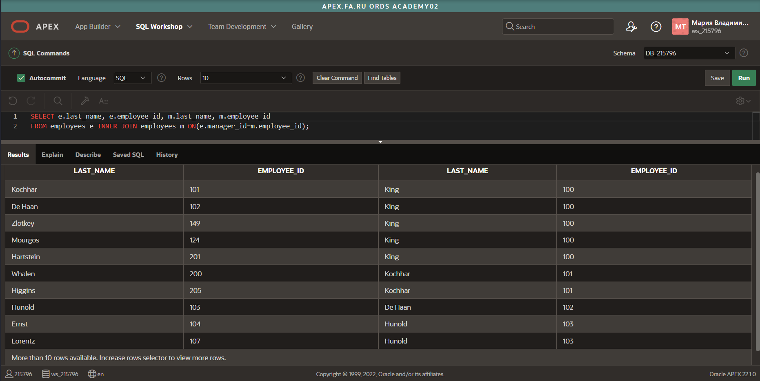

1. Modify question 1 to display all employees and their managers, even if the employee does not have a manager. Order the list alphabetically by the last name of the employee.

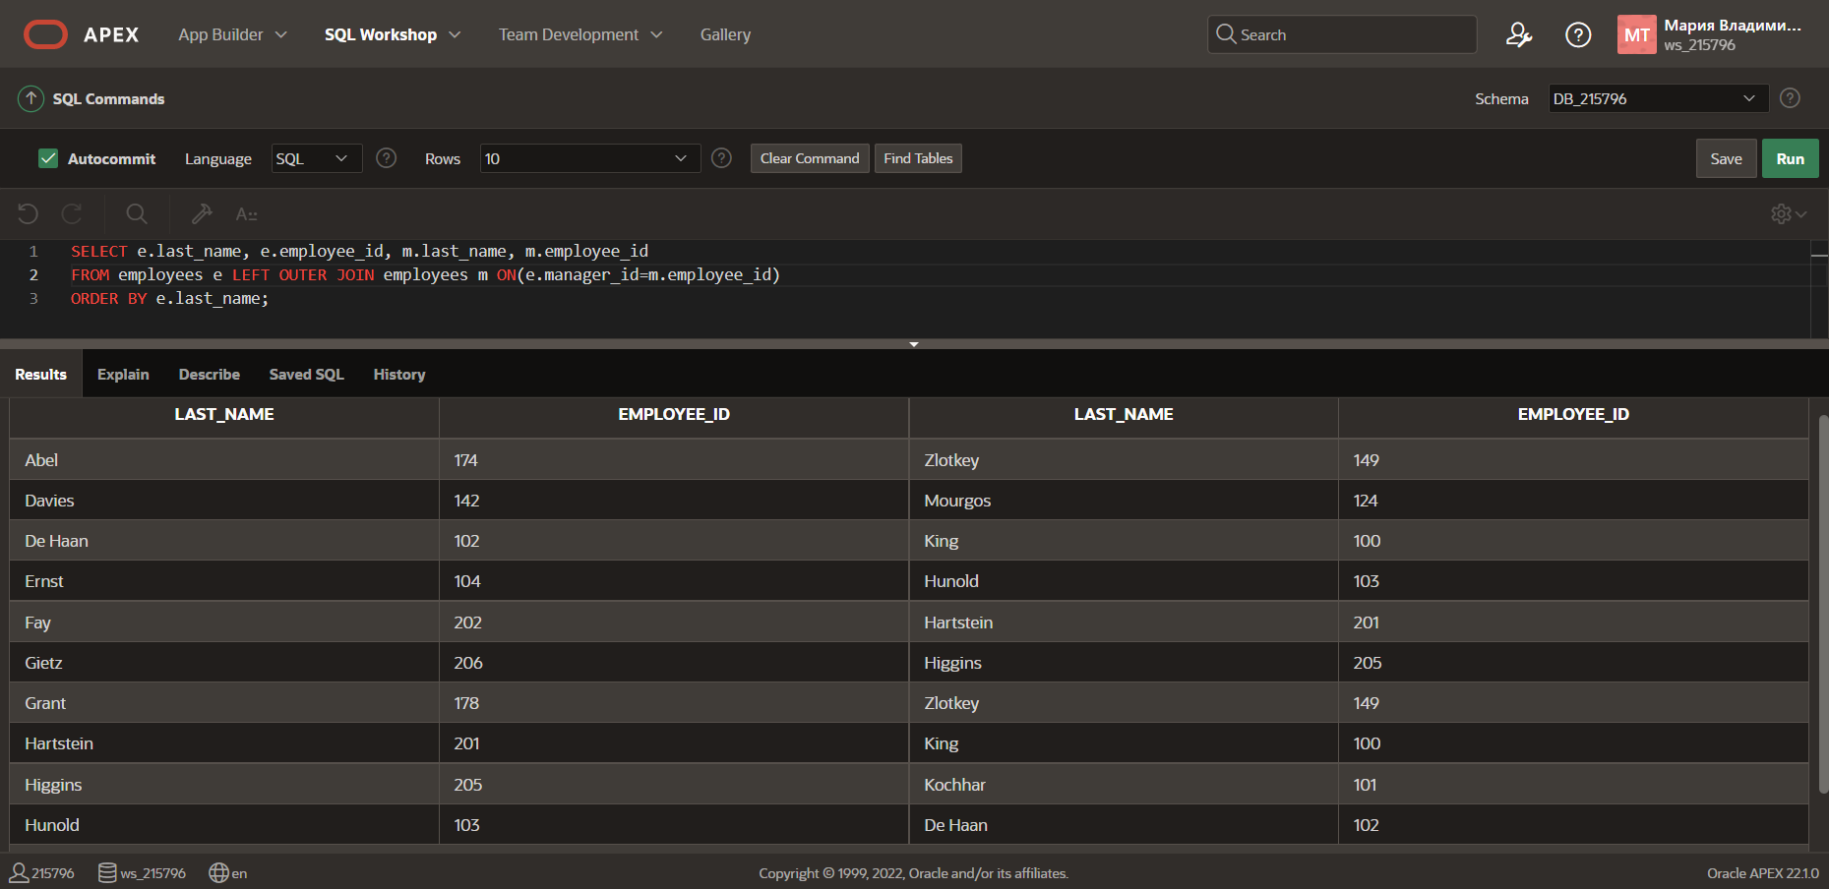

1. Display the names and hire dates for all employees who were hired before their managers, along with their managers’ names and hire dates. Label the columns Employee, Emp Hired, Manager and Mgr Hired, respectively.

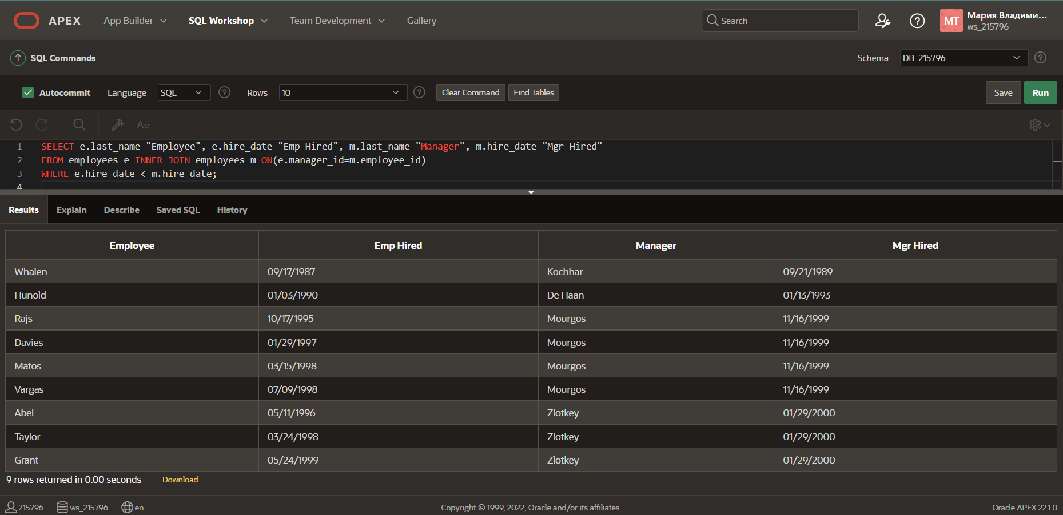

1. Write a report that shows the hierarchy for Lex De Haans department. Include last name, salary, and department id in the report.

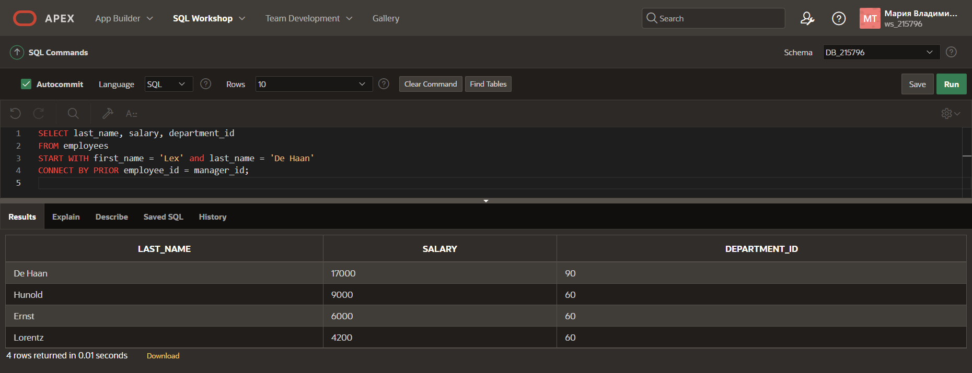

1. What is wrong in the following statement?

SELECT last_name, department_id, salary

FROM employees

START WITH last_name = 'King'

CONNECT BY PRIOR manager_id = employee_id;

В запросе ошибки нет, только если в логике, потому что иерархия будет строиться не от самого главного к подчиненным, а наоборот

1. Create a report that shows the organization chart for the entire employee table. Write the report so that each level will indent each employee 2 spaces. Since Oracle Application Express cannot display the spaces in front of the column, use - (minus) instead.

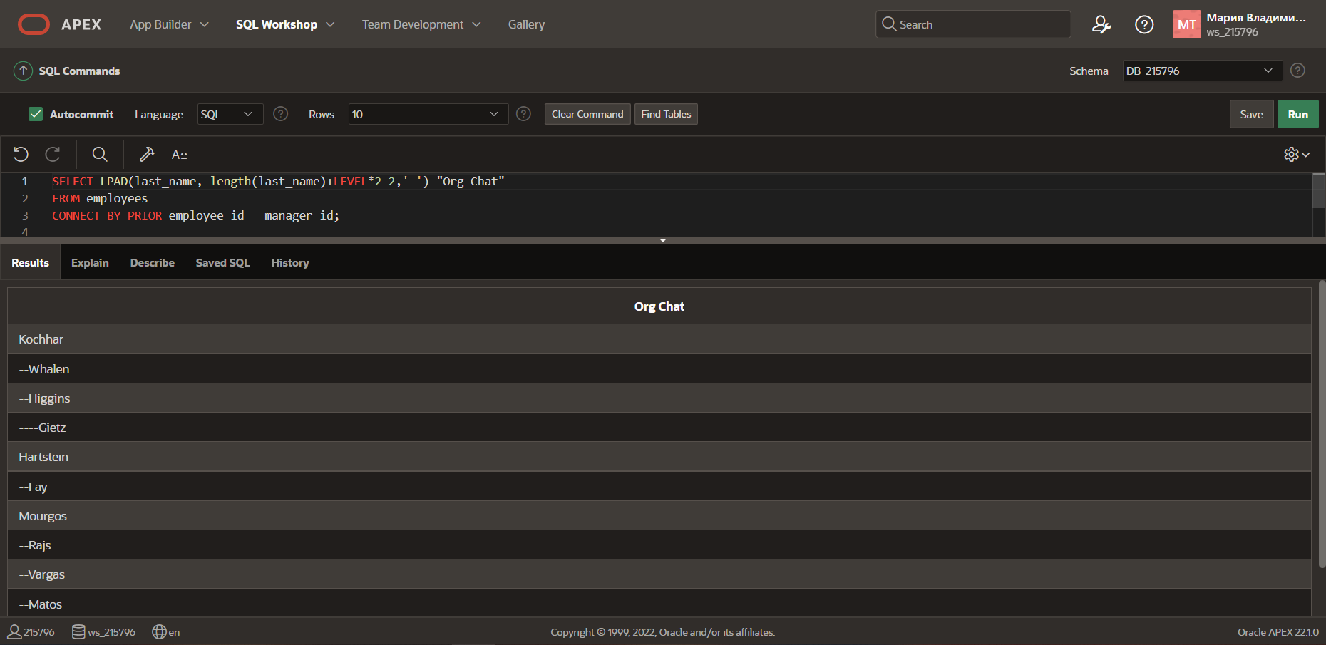

1. Re-write the report from 6 to exclude De Haan and all the people working for him.

